- Documentation
- Documentation
- Release Documentation

3.3 Release Update
Skip to end of metadata

- Created by Craig Roberts, last modified by Lynnette Robinson on Apr 30, 2015
Go to start of metadata
- Till
  - New Option to stay in PLU (Keyboard) screen until the home button is pressed.
  - New Option for Account Searching
  - Manually Enter Weight of a weighed article
  - Account Searching Maximum Results
  - Account Optionise Reference 2
- Back Office
  - Cost Centres For Deli Management
  - Highlight the need to release prices on Label Print
  - 4 decimal places now supported in cost field
  - New Search For Deals
  - Multiple Activation of Deals
  - External Accounts Fields On Commodity Group
  - Linking an Order when creating a Goods Received note on the Back Office
  - Range Updates for Cost Prices
  - New Line Count Column in Goods Receiving
  - Improvements to Transaction Viewer
  - Export & Upload BP Fuel Report in EOD
  - Cash Control - Lock Down Set Shift Day
- Head Office
  - Cost Centres For Deli Management
  - New Search For Deals
  - Multiple Activation of Deals
  - External Accounts Fields On Commodity Group
  - Retailer Drop Down Read Only
  - Range/Shop Selection Updates for Cost Prices
  - Group Info Screen
  - Option to force price changes to all shops
  - Option to force Deal changes to all shops
  - Checking if Pricing Transferred to Back office(s)
  - New HO Status Screen showing BO status
  - Improvements to Transaction Viewer
- General
  - DB Backups are zipped on creation
- Reports
  - Fuel Discount Card Report

Till

New Option to stay in PLU (Keyboard) screen until the home button is pressed.
A new Till\BO option has been added to allow a user to stay in PLU (Keyboard) screen until the home button is pressed. Once a plu button is pressed it will add the item to the basket, but stay in the PLU screen. The button will then show the current qty of the item added to the basket and a new button to decrease the amount in the basket. Other plu buttons can then be pressed to add additional items to the basket.
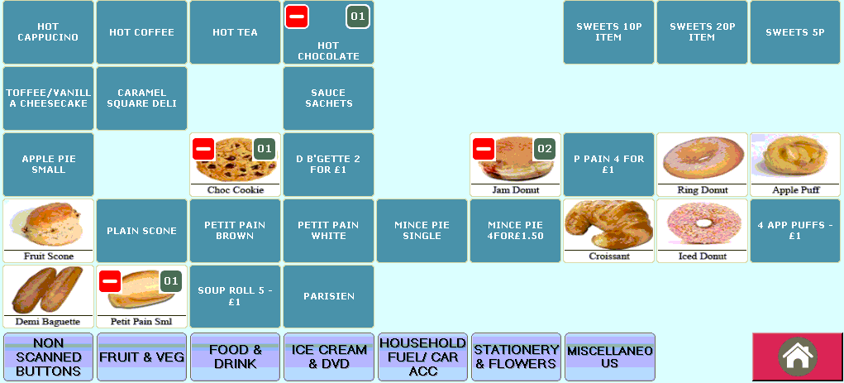
You can only decrease the amount to 1. The usual voiding functionality needs to be used to remove the line completely from the basket.
Weighted and Open items will go automatically back to the basket screen. Also any lines that need to be void must be done via the basket screen using the normal process.

New Option for Account Searching
ED-2374
New option in the Back Office settings to choose if the till account searching is to be done by the external account reference. If this option is not set it searches by account number. This is used in both account payments and account tendering.
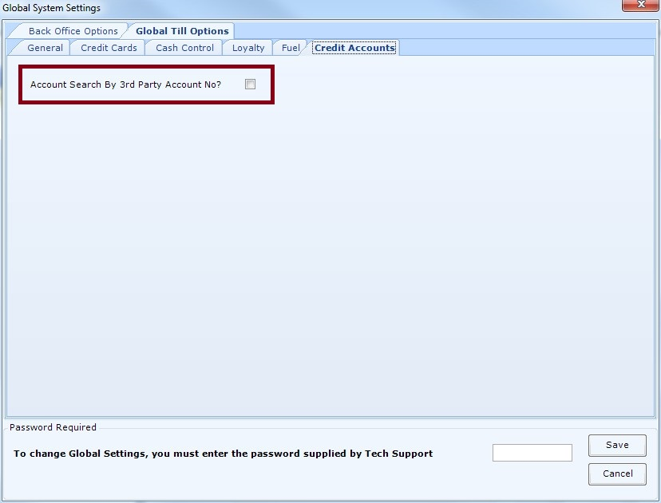
If set the "3rd Party Acct No" is searched by and displayed in the "Number" column. If not set the "A/C No" is searched by and displayed in the "Cust No" column.
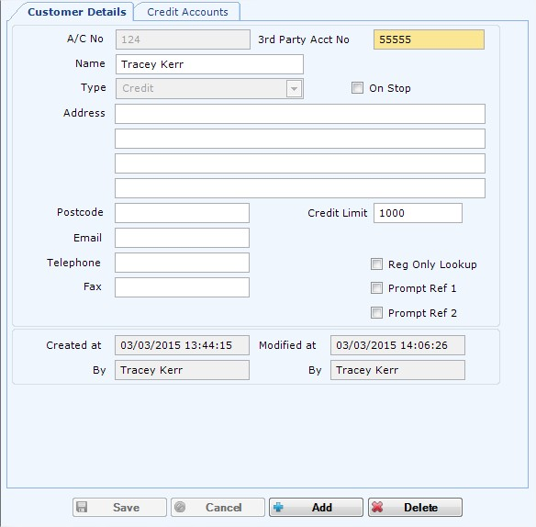
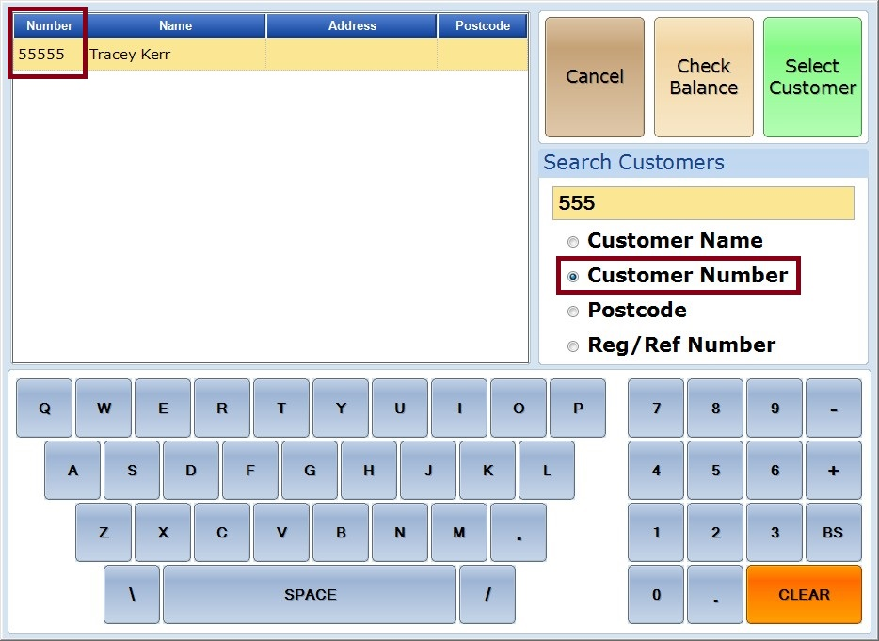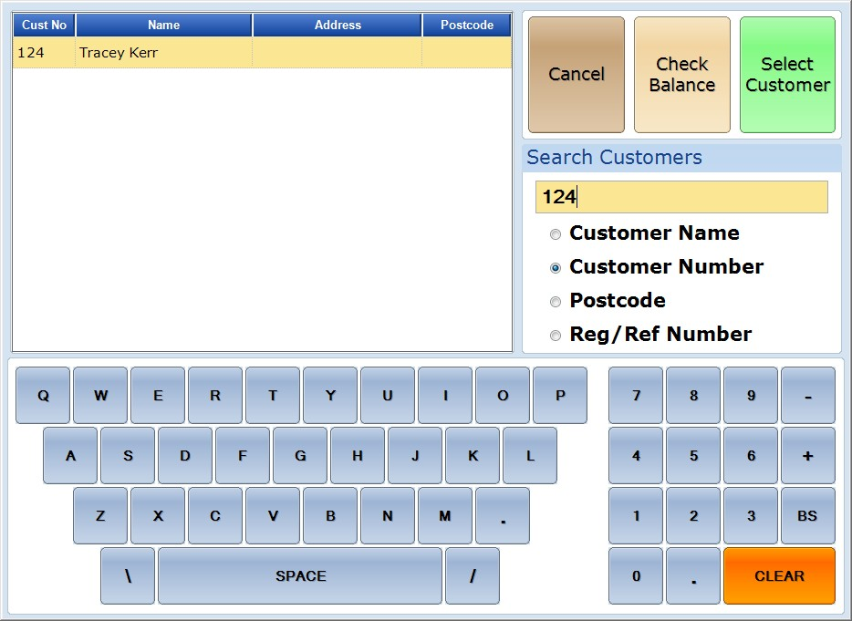

If option is set sub accounts will not be searched as they currently do not have the 3rd party account reference field.

Manually Enter Weight of a weighed article
3.3.1
There is a new option to enter a weight of a weighed article if you have scales that are not integrated. If the scale port setting is set to manual then all weighed articles will get prompted for the weight to be entered.
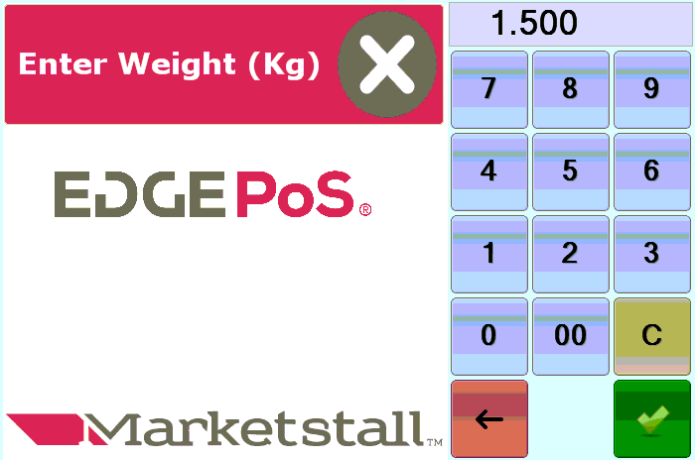

Account Searching Maximum Results
3.3.1 ED-2534
When searching for a customer account on the till there is now a maximum number of results which is set to 200. This means that if there are more than 200 customers matching the criteria searched for none will be shown. If the search is then narrowed down (to less than 200 results) by providing more information in the search box the results will be shown. This is to prevent freezing issues when the grid is populating thousands of results on each character input.

Account Optionise Reference 2
3.3.1 ED-2577
There is now a Global Till Option on the BO to disable and hide the Reference 2.
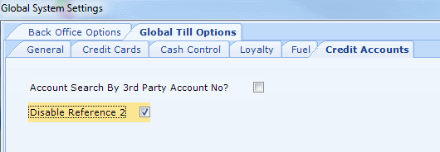
When this is flagged the field is hidden on the Account Lookup on the till and also the Prompt Ref 2 in Customer Maintenance on the BO.
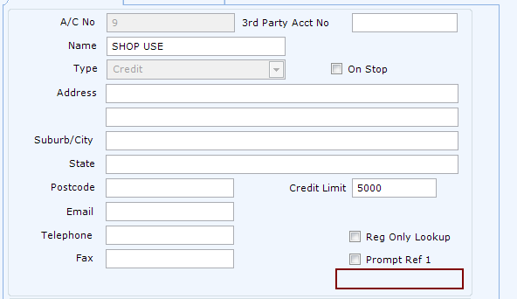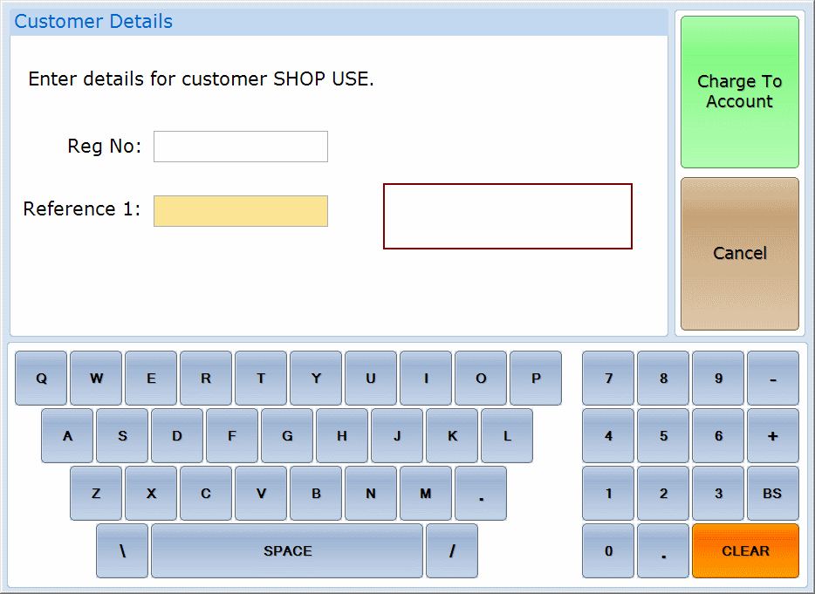
.

Back Office

Cost Centres For Deli Management
ED-2150
Cost centres can be set up to enter accurate costs for an entire department or commodity group before running either the CG Sales & GP or CG Sales & GP (VAT Exc) reports. All information can be found in the how-to guide.

Highlight the need to release prices on Label Print
ED-2282
Added new message box highlighting the need to release prices at a later date if No is selected when printing labels.
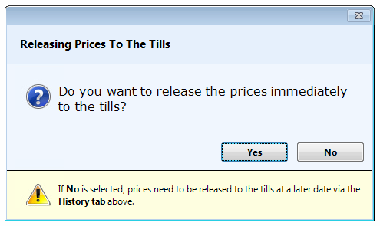
On the History tab a new column has been added to show label batches that still have prices to print.
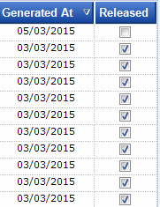

4 decimal places now supported in cost field
ED-2020
UnitCost and CaseCost fields in grLine and batchline tables now support 4 decimal places. If a 4 digit case cost is displayed at the end of a product, invoice or price change file then this is displayed in the case cost column otherwise the original case cost value in the line is displayed.
- Case cost at end of line:
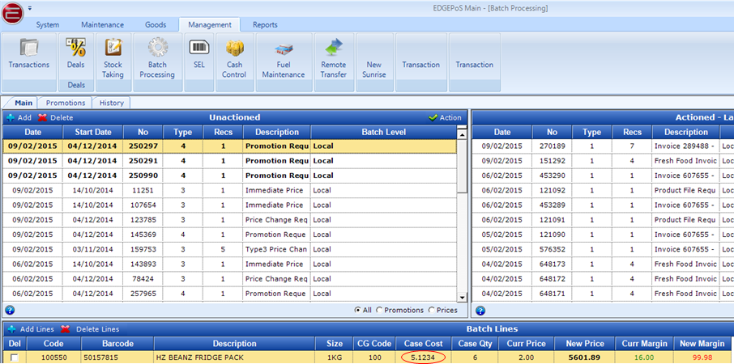

- No case cost at end of line:
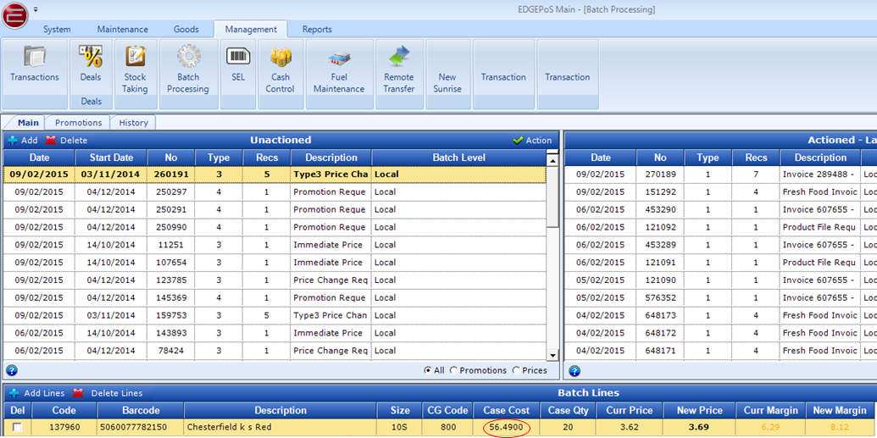

New Search For Deals
ED-1790
The new search screen will automatically replace the old PLU lookup window when adding articles to a new deal or when updating a deal. Details can be found in the new search how-to guide.

Multiple Activation of Deals
3.3.1
ED-2499
Multiple deals can now be selected for simultaneous activation, similar to delete functionality:
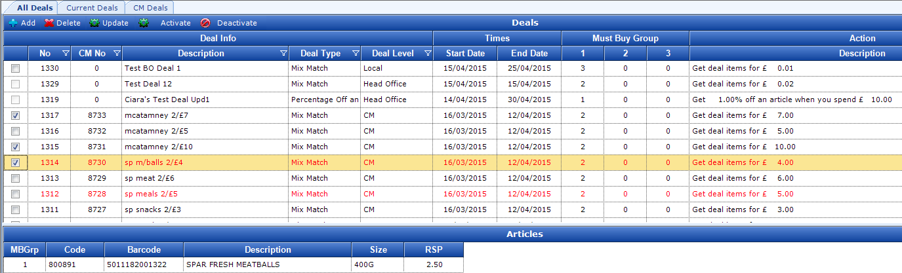

External Accounts Fields On Commodity Group
ED-2362
New fields to save the external account details against the commodity groups - Dept Code and VAT Ref (GST Ref in Australia). If a Head Office system this is controlled at HO.
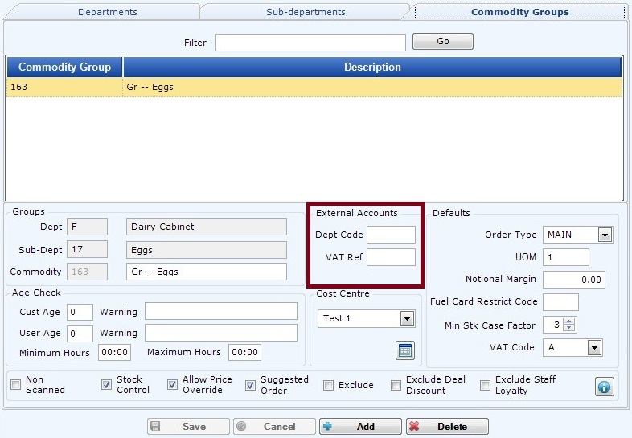

Linking an Order when creating a Goods Received note on the Back Office
ED-2292
You can now create a Goods Received using an existing Completed Order on the system.
When adding a GRN there is an extra field to enter or lookup an order.
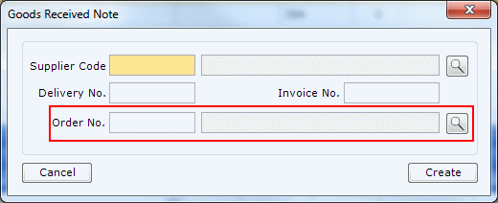
Full info on how to use this can be found in the how-to guide Goods Receiving - Linking an Order.

Range Updates for Cost Prices
ED-2390
When updating or adding supplier prices via Article Maintenance,there is now an option to update by Range.
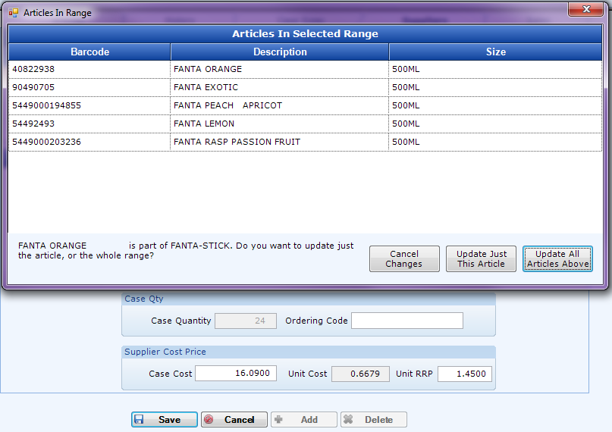

New Line Count Column in Goods Receiving
3.3.1
A new column has been added the the GR head to show the number of lines associated with the goods receiving invoice.

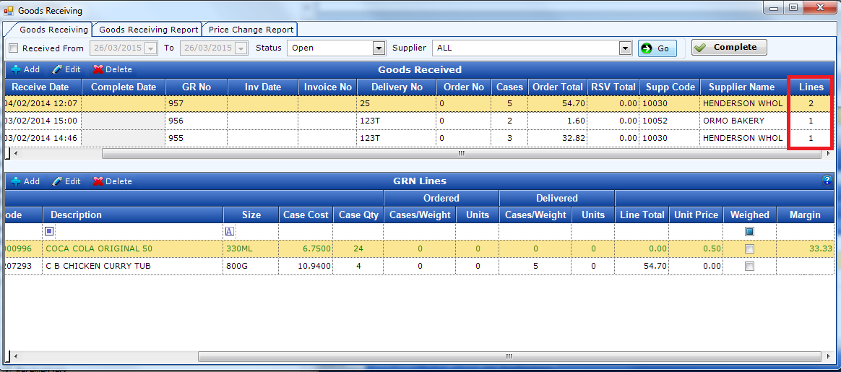

Improvements to Transaction Viewer
3.3.1
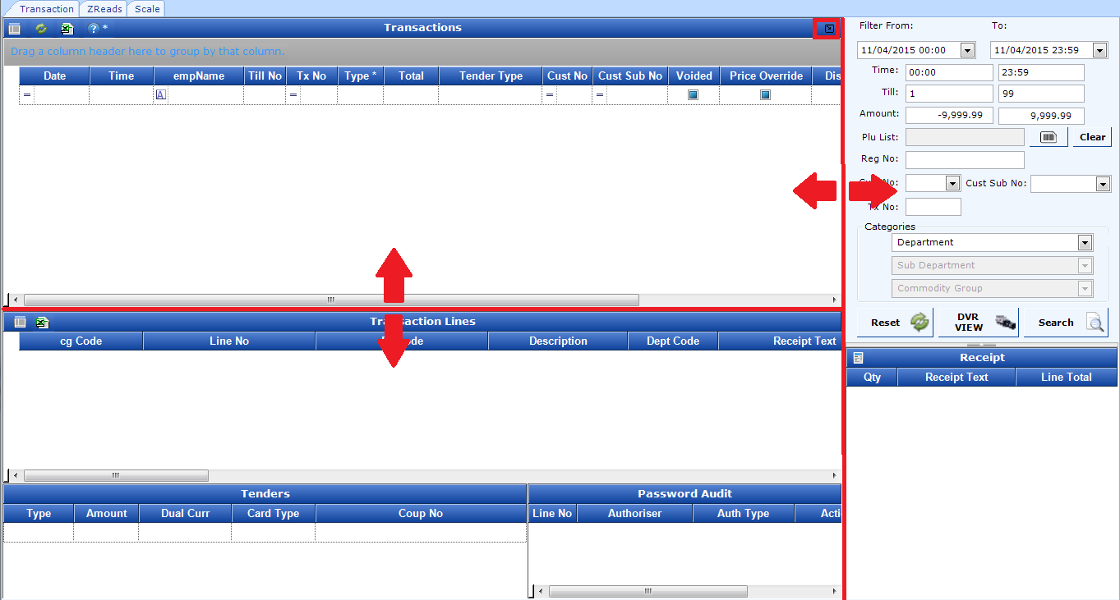
The size of the transaction header grid can be increased by dragging below the grid. The size of the filter panel can be reduced by dragging the left hand side of it.
The whole transaction screen can be maximised by click the new button on the top right of the panel.
The column state of the transaction head grid and transaction line grid are saves on exit of the screen an are the same on reentry of the screen.

Export & Upload BP Fuel Report in EOD
3.3.1 ED-2507
There is a new option to export the fuel sales for the previous day and then upload this report to the update server (which will then be transferred to the server at BP). Details on this can be found at BP Commission Agent Report - Automatic Collection. To run this during the EOD process the BO option below must be turned on:
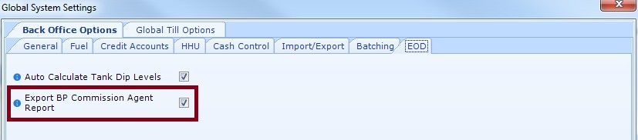

Cash Control - Lock Down Set Shift Day
ED-2579
3.3.1
This has been implemented as an option to lock down Cash Control. The the BO options simply tick Lock Down Cash Control to stop the ability to change the Shift Day as detailed below.
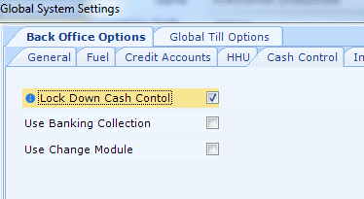

When the option is flagged, set Shift Day has been locked down so that once a Shift Date is set against a shift, it CANNOT be changed!! Warnings have been added in make the user aware of this.
If a mistake is made then only Support can update it!
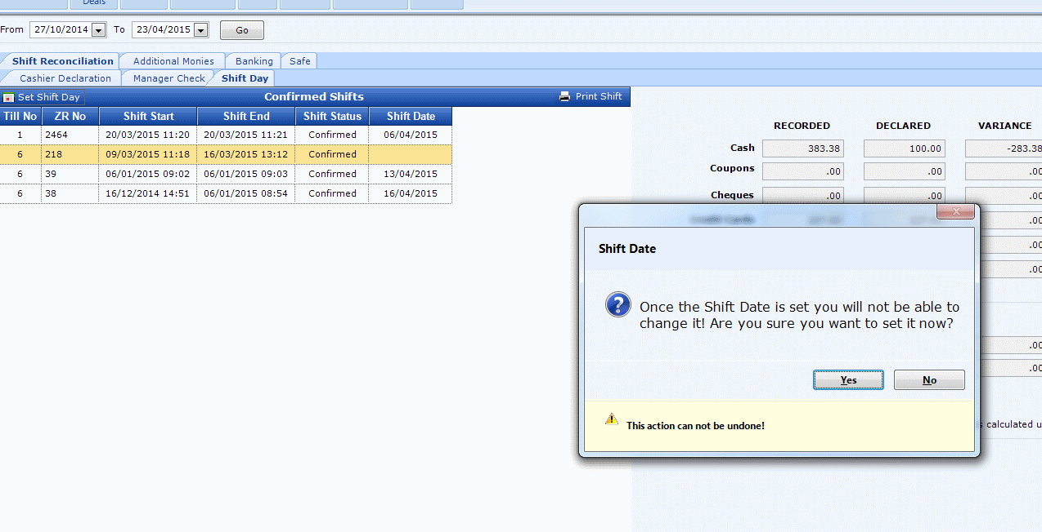
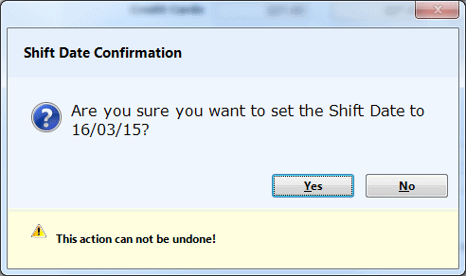

Head Office

Cost Centres For Deli Management
ED-2150
Cost centres can be set up to enter accurate costs for an entire department or commodity group before running either the CG Sales & GP or CG Sales & GP (VAT Exc) reports.
If a Head Office system the cost centres must be maintained at Head Office for all shops. All information can be found in the how-to guide.

New Search For Deals
ED-1790
The new search screen will automatically replace the old PLU lookup window when adding articles to a new deal or when updating a deal. Details can be found in the new search how-to guide. At head office the details of all shops will be displayed in the search when articles expanded.

Multiple Activation of Deals
3.3.1
ED-2499
Multiple deals can now be selected for simultaneous activation, similar to delete functionality:

External Accounts Fields On Commodity Group
ED-2362
New fields to save the external account details against the commodity groups - Dept Code and VAT Ref (GST Ref in Australia).

Retailer Drop Down Read Only
ED-2404
Updated the retailer drop down to be read only in the screens it is not needed. This is to remove confusion over when it can be used.
Example of read only when not needed in the suppliers screen and not read only in the fuel maintenance screen:
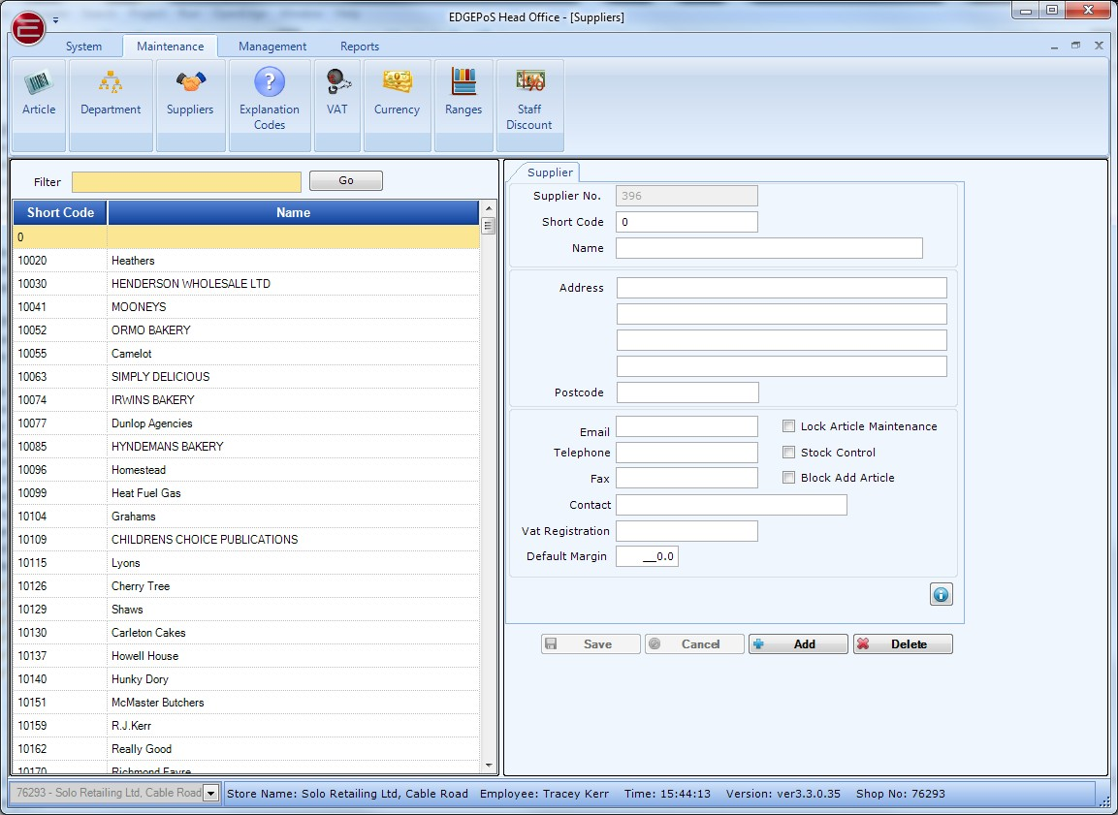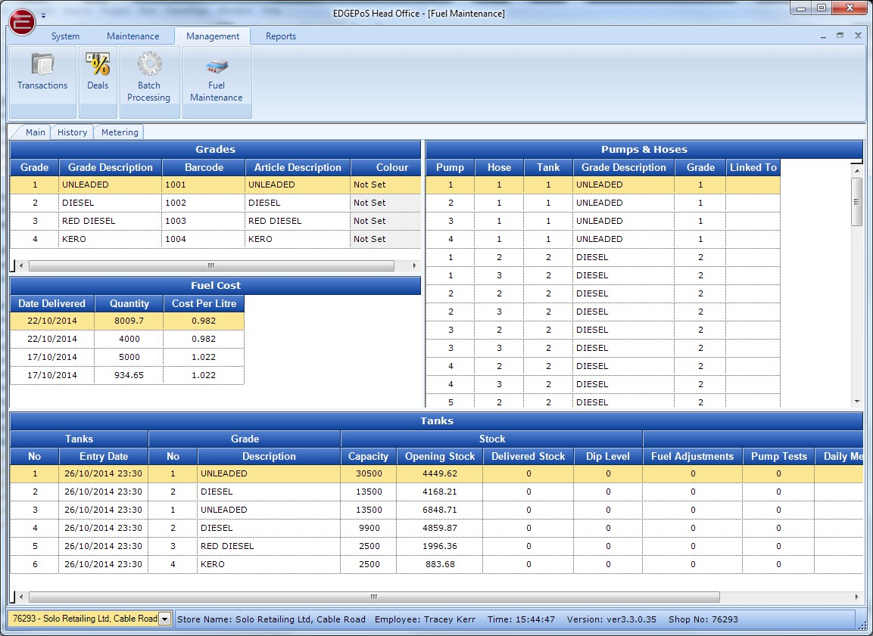

Range/Shop Selection Updates for Cost Prices
ED-2390
When updating or adding supplier prices via Article Maintenance,there are now options to update by Range and also by Shop Selection.
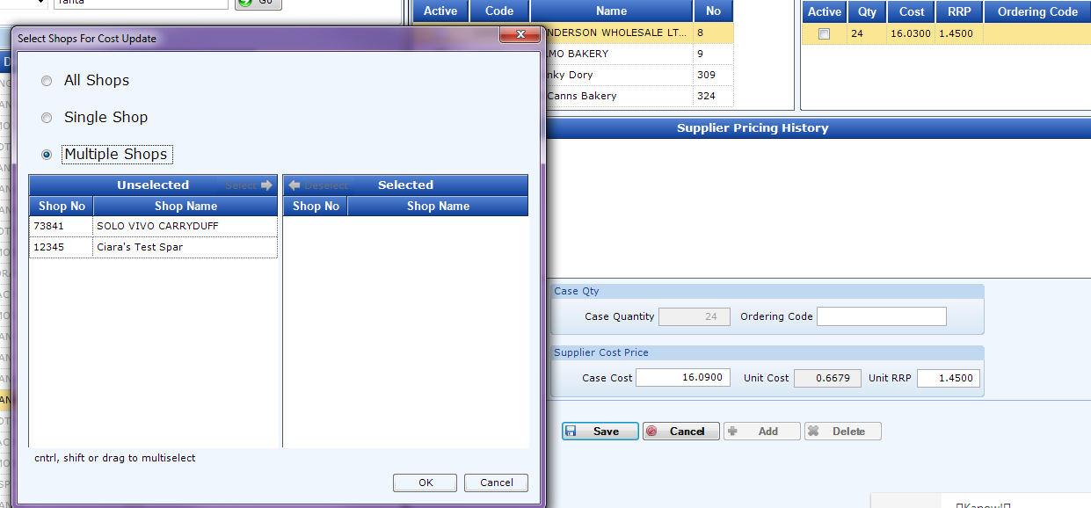

Group Info Screen
There is a screen at Head Office to enter Group Info.
If this is populated it will be used in the account reports.
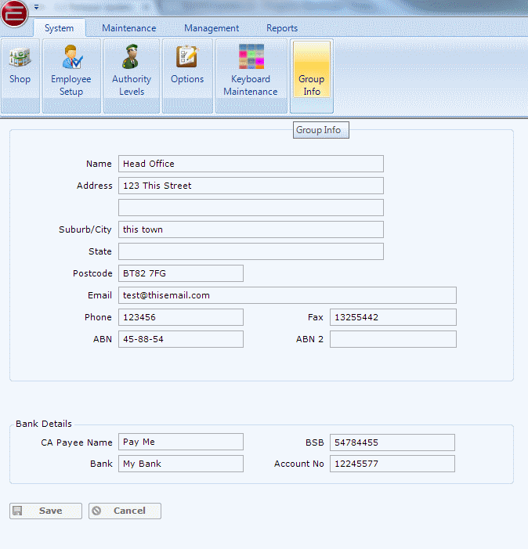

Option to force price changes to all shops
ED-2495
When this option is selected at HO the screen for shop selection is not displayed, all shops are automatically selected when a price change is done in article maintenance.
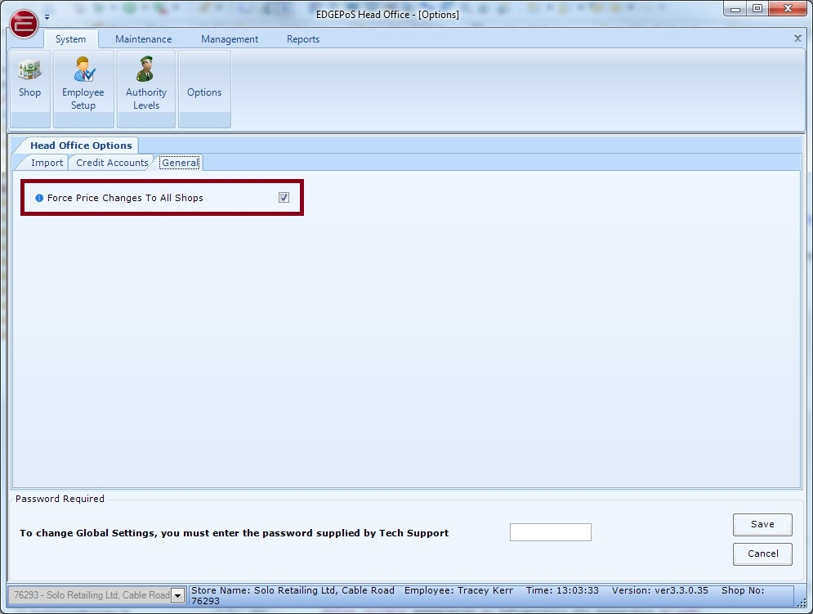

Option to force Deal changes to all shops
3.3.1
ED-2564
When this option is selected at HO the screen for shop selection is not displayed, all shops are automatically selected when a deal is activated, deactivated, or edited at the Head Office.
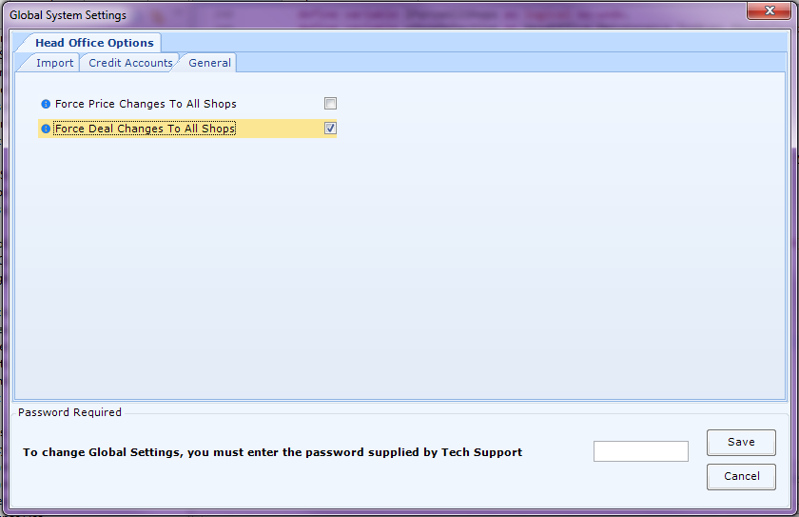

Checking if Pricing Transferred to Back office(s)
ED-2494
In Global Pricing at Head Office there is now an extra column that shows whether a Back Office has received new pricing created at the Head Office.
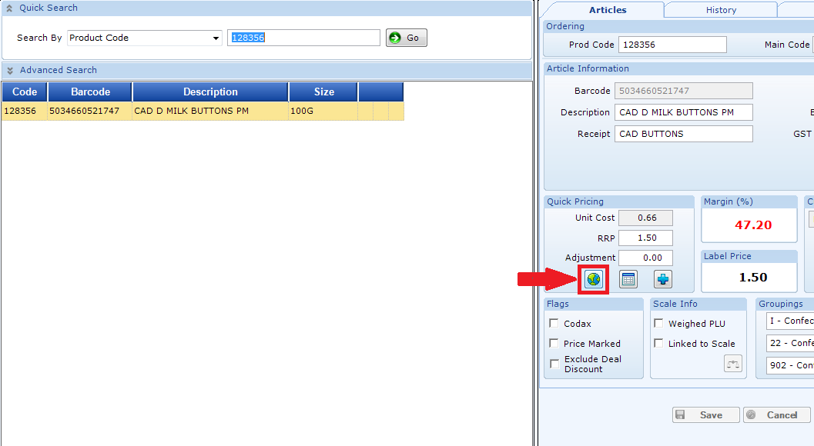
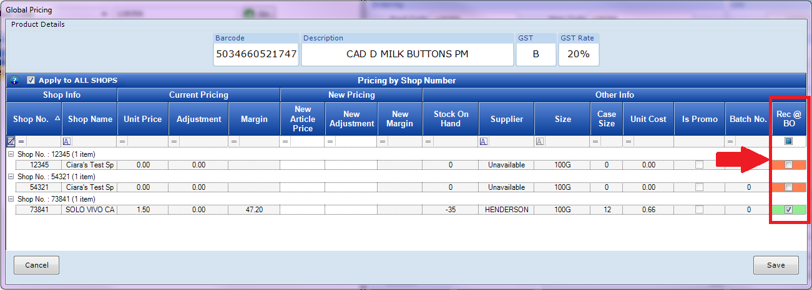

New HO Status Screen showing BO status
HeadOffice now show the status of all stores connected to it. This is updated every minute.
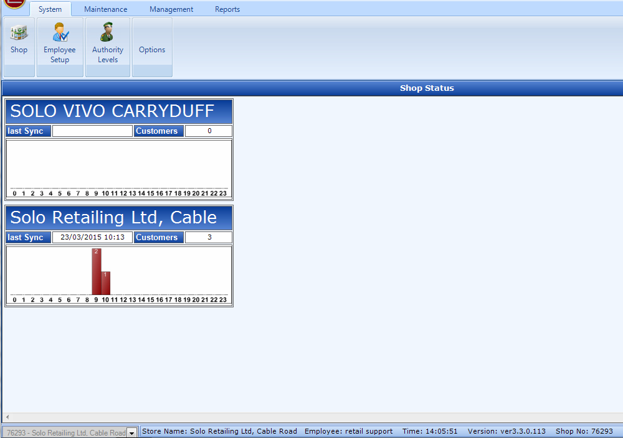

Improvements to Transaction Viewer
3.3.1
The size of the transaction header grid can be increased by dragging below the grid. The size of the filter panel can be reduced by dragging the left hand side of it.
The whole transaction screen can be maximised by click the new button on the top right of the panel.
The column state of the transaction head grid and transaction line grid are saves on exit of the screen an are the same on reentry of the screen.

General

DB Backups are zipped on creation
ED-2311
All EOD backups are now zipped with an information file to easily identify the backup.

Reports

Fuel Discount Card Report
3.3.1
ED-2578
Added a new parameter to the report run called Group By.
You can select to group the info by Fuel Type or Card Type. The default is Fuel. This then gives you a sub total on the report for the selected Group By.
